How does wool keep you warm even when it's wet?
by Charles W. Bryant
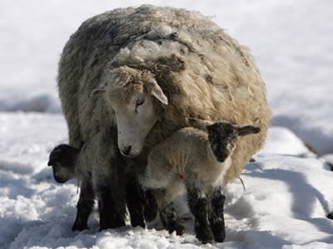
Image Gallery: Mammals

Image Gallery: Mammals This mother sheep helps to keep her little lambs warm while their coats are still growing. See more pictures of mammals.
Matt Cardy/Stringer/Getty Images

UP NEXT
- How does bug- repellent clothing work?
- Why is cotton more absorbent than nylon?
- PlanetGreen.com: Sweater Care Tips
To the untrained eye, a sheepmight look like a big, dumb heap of wool standing around in the rain. What you might not know is that the wool on a sheep's back is actually a sophisticated web of fibers that may well be the most versatile and useful animal product on Earth, outside of perhaps leather. That same sheep milling about a field in the cold wetness is actually keeping pretty dry and warm underneath, thanks to the amazing characteristics of its "sweater."
At the beginning of 2008, there were about 6.1 million head of sheep in the United States. That's a lot of wool, but nothing compared to New Zealand. The old joke is that sheep outnumber people there 20 to one. While that's not quite the case, it isn't too far off. There were about 4.3 million people living in New Zealand in March 2009 [source: stats.govt.nz]. Agricultural production statistics in June 2008 placed the number of sheep in New Zealand at just under 34 million head [source: stats.govt.nz]. That means there's almost eight sheep for every one New Zealand resident. If the same were true in the United States, there would be about 2.4 billion wooly creatures roaming the fruited plains.
Most of the 46.5 million pounds (21 million kilograms) of wool produced in the United States is sheared during the spring months [source: American Sheep Industry Association]. The average weight of a sheep's wool, or fleece, in the United States is about 8.3 pounds (3.7 kilograms), but some sheep can have as much as 30 pounds (13.6 kg) of the thick insulator in other parts of the world [source: sheep101]. One thing is for sure -- 30 pounds of wool, even in the pouring down rain, will keep a sheep warm and toasty thanks to the unique nature of this wonder fiber.

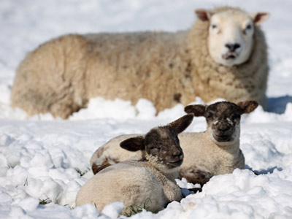
Thanks to wool, even the cold snow can't penetrate to the sheep's skin.
Matt Cardy/Stringer/Getty Images

Wool: The Wonder Fiber
Wool has some unique properties that make it one of nature's most amazing fibers. Firstly, wool is resistant to fire. It will burn if it's held to an intense fire, but when it's removed from the flame, it will self-extinguish. The reason is that each and every wool fiber contains moisture. It's also an incredibly flexible and durable fiber; one fiber can be bent back more than 20,000 times without breaking and is said to be comparatively stronger than steel [source:American Sheep Industry Association]. To put this in perspective, a cotton fiber can only be bent 3,000 times before it breaks. Its natural elasticity makes it resistant to tearing as well. Wool fibers can be stretched as much as 50 percent of their original length when it's wet and about 30 percent when dry [source: American Sheep Industry Association].
Wool is also a pretty smart insulator. Think of it like a thermos for your body -- it can keep you warm or cool depending on your needs. It keeps you warm without overheating your body and in the Sahara Desert, Bedouins wear thin wool to keep them cool in the searing heat. The secret to both of these facts are the tiny pockets of air within each wool fiber that provide both insulation and breathability (we'll get into this little more on the next page). If that's not enough, it's also resistant to mold and mildew. It's no wonder humans domesticated the sheep in 8000 B.C.
Wool is also able to soak up as much as 30 percent of its own weight in moisture without feeling wet, which is one of the reasons it can still keep you warm even in the rain [source: American Sheep Industry Association]. The fibers have a natural crimp that helps to wick moisture away from the body. Getting this moisture off your bare skin is a key element to keeping warm in wet conditions. But there are some other more complex elements to the wool fiber that aid in warming you in the wetness, as well. We'll take a look at those on the next page.

